Week 1 Discussion 1: Organization Design and its Major Components
Student’s Name
Institutional Affiliations

Week 1 Discussion 1: Organization Design and its Major Components
Organizational design is a procedural arrangement that identifies incoherent aspects of work performance, processes and systems then embarks on realigning them to adequately address desired business goals. According to Burton, Obel & Håkonsson (2020), from this definition, the organization, therefore, develops a plan to device the new changes. The said changes consequently impact both company workforce and technical aspects of the organization. Friesen (2005) illustrates that the assurance of organization design process is creating a complete and all-inclusive approach that leads to organizational advancement.
Organization design takes into account chartering the whole organizational processes as a component. The design team works with critical stakeholders like the management and employees in some areas to audit business results analyze organizational wellbeing and determine its market and environmental demands. As discussed by Obel & Håkonsson (2020), this is the charter that will provide an effective roadmap to establishing a design process. From all these areas, a need or necessity for conducting the design process will be attained. Then, assessment of the existing state of the business in the organization in order to understand how it functions, what constitutes the business strengths and weaknesses are researched before aligning them as core principles and business strategy that the aimed design will improve (Friesen, 2005).
Furthermore, the next component becomes the design itself. At this phase, the definition of conceptual organization principle is carried out. This is the main principle that the design seeks to improve. Based on the charter findings in the first component, the design at this stage may focus on elements such as functions, customer-types and definition of the needed skills, as illustrated by Sitar & Škerlavaj (2018). Most researchers posit that at this stage, there is relevance for establishing performance metrics for each function or structure of the team in order to maintain and keep their operations in check. Lastly, the implementation of the design is the component that forties the new processes of operating the organization’s business. The organization’s workforce becomes organized into naturally cultured workgroups. The leadership of the organization should provide training in the new design so as to keep its people abreast with present issues and expectations of the new design (Sitar & Škerlavaj, 2018). Implementation of the new design through training of staff improves the previous roles that were underserved in the organization before the new design.
An Image Illustrating Innovation
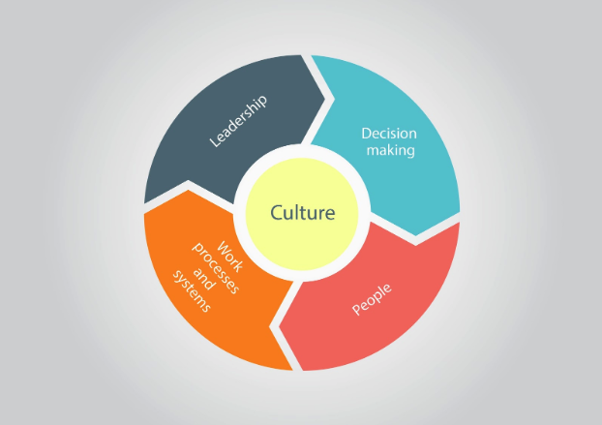

References
Burton, R. M., Obel, B., & Håkonsson, D. D. (2020). Organizational Design. Cambridge University Press.
Friesen, B.G. (2005). Organization Design for the 21st Century. Consulting to Management, 16(3), pg. 32. ProQuest
Sitar, A. S., & Škerlavaj, M. (2018). Learning-Structure Fit Part I: Conceptualizing The Relationship Between Organizational Structure And Employee Learning. The Learning Organization, 25(5), 294-304.

